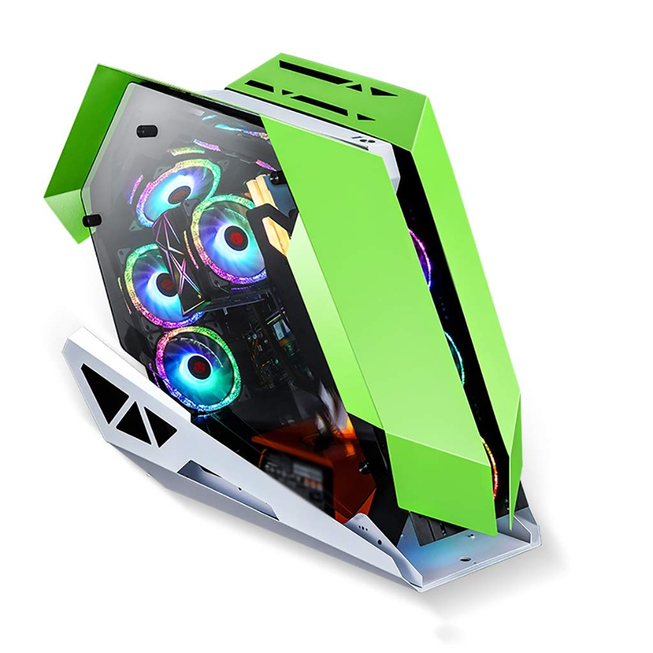

NEW GAMING PC - CORE I5 10400F - 10TH GEN BOOST UPTO 4.30GHZ - RAM 16GB DDR4 - 256GB SSD - 500GB HARD - SIDE GLASS RGB CASE - GTX1660 GDDR5 6GB GRAPHICS CARD

* Custom Build New Gaming PC
* Asus/MSI H410 Motherboard
* Core i5 10th Generation
* Core i5 10400F
* Base Clock : 2.90Ghz
* Max Turbo : 4.30Ghz
* 6 Cores 12 Threads0
* RAM : 16GB DDR4

GAMING PC